Notes

Hi Ags,

I want the main website page to be the gallery page. The paintings will be displayed in a grid going downward with three paintings per row. The paintings will be displayed in reverse chronological order of their date of completion with the most recent paintings going at the top.

I am using a responsive web design, which means that how many pictures you see in a row will depend on the monitor or tablet or phone size. So for a large monitor, it will be 4, then 3, then 2, then 1 as the screen size gets smaller.

The backdrop colour for these paintings will likely be either hale navy (Benjamin Moore) #444c57 or Naval (Sherwin Williams) #2F3D4C

Single colour palette based off of Hale Navy
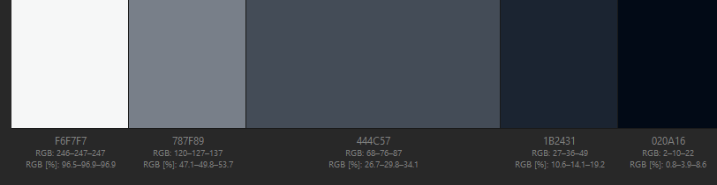
#F6F7F7 #787F89 #444C57 #1B2431 #020A16

Single colour palette based off of Naval
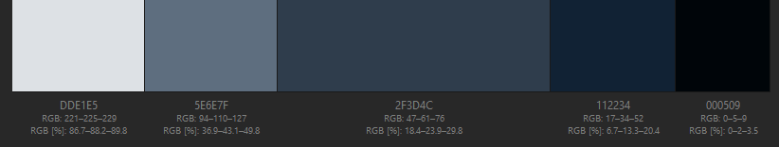

#DDE1E5 #5E6E7F #2F3D4C #112234 #000509

Natasza Zurek Art will be displayed in white font in the top title , just not sure what font to use yet and if you have ideas for font please let me know.

Each painting will have a thin white border around it, and the name of each painting will be under the picture. They won’t be clickable to enlarge.

Ok, in that case I’m going to save a smaller version of each picture so that they will be less attractive to steal and so they load faster. If at another point you wanted to include the larger versions, we could always put a watermark and copywrite over them.

There will be a ‘shop’ menu option in the menu bar once we get the shop feature figured out. The shop will have three offers: original paintings, limited edition paintings, and prints.

Once we get a shop feature sorted, I think it makes sense to make each picture a link to the shop

There will be a bio link in the menu bar with my write up and picture once you click the link.

There will be a contact link in the menu bar which will include my email and links to my Instagram and Facebook

There will be links to my Instagram and Facebook in the bottom banner.

I’ve added icons for Instagram and facebook. There are hundreds of icons to choose from. Let me know if you like the ones I found. If you’d rather browse for icons yourself, look here. Some are free and some are paid https://www.freepik.com/popular-icons

List of order of paintings in gallery (starting with the newest which will be at the top)

- Cosmic Kitty (2019)
- Biorhthms (2019)
- We Are Made of Stardust (2019)
- Colorgasm (2018)
- Joy Therapy (2018)
- Repatterning (2018)
- A Prayer For the Eagles II (2018)
- Sacris Sacramentum (2018)
- Dualistic Nature (2017)
- Elephant (2017)
- The World Is Made of Language (2017)
- Starlit (2017)
- Bineaural (2017)
- Birth Story (2017)
- Peek Experience (2017)
- Mallard (2016)
- Fox (2016)
- Duck (2016)
- Spirit Bear (2016)
- Snail (2016)
- River (2016)
- Raccoon (2016)

It’s looking great already!

I think the pinline borders are too skinny. I will send you pic of an example of what I am thinking. The white skinny border will go right up to the edge of the paintings, so it will be a painting outlined in white on top of the bluish grey back drop. And the painting titles will be in black. (no artist name as in the example, just the painting title)

